Get started at Xpressdocs. GO to access.SIR.com and select Product Studio (xpressdocs)

An Authentic Network | Connected Worldwide | Known for Exemplary Service | Marketing Beyone the Extra…
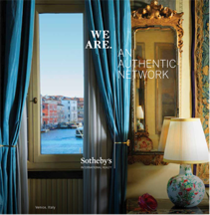 |  | 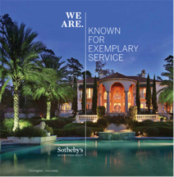
Power of the Network | Global Reach | Our Heritage | Global Media Relationships
Exclusively Innovative | Leveraging Our Heritage | The Voice of Luxury Real Estate | Breaking Records
 | 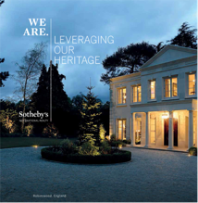
Marketing Platform | Art & Home | Wealth X | Record Sales

An Authentic Network  Power of the Network | My network is comprised of like-minded professionals that put client’s needs first. This means that no matter what part of the world you are in, you will find a qualified Sotheby’s Realty associate to achieve your goals. The value of our Sotheby’s Realty Network is the seamless connection we share with partners around the world.  I am a local expert with global connections. When listing a property, I can guarantee maximum exposure throughout the local and global real estate community.  Visit my Facebook page or call me for all of your real estate needs!
Connected Worldwide  Global Reach | Connected worldwide means that with almost 20,000 sales associates in over 60 countries around the globe, I have the ability to extend the reach and appeal of a home far beyond the local market. At Sotheby’s Realty, we have aligned ourselves with quality people around the globe to ensure seamless, white-glove service. We can provide boundless connections between buyers and sellers to successfully market the homes we represent.  Visit my Facebook page or call me for all of your real estate needs!

Get started at Xpressdocs. GO to access.SIR.com and select Product Studio (xpressdocs)

Known for Exemplary Service  Our Heritage | I am proud to announce my affiliation with the Sotheby’s International Realty Network, specializing in our local market. We have aligned ourselves with the most experienced real estate professionals in the world. The seamless flow of information has allowed us to learn from the best practices and marketing techniques in the global real estate industry.  Visit my Facebook page or call me for all of your real estate needs!
Marketing Beyond the Extraordinary  Global Media Relationships | Utilizing several worldwide and strategic media partners, our marketing plan delivers over 1 billion media impressions with a truly global impact. Our partners have been specifically chosen to extend the reach and awareness of our available properties. Our approach allows us to connect buyers and sellers across all channels.  Please contact me to discuss the local real estate market, or available properties around the world.

Get started at Xpressdocs. GO to access.SIR.com and select Product Studio (xpressdocs)

Exclusively Innovative  Marketing Platform | When listing a property, I represent a home in a highly visual way. Our platform creates an immersive experience with rich photography and effective distribution.  Locally, we enable all of our associates and competitors to find information about our listings. In the last 6 months, we have had over one million people view our listings.  To discuss the local real estate market, or available property around the world, please contact me or visit my office!
Leveraging Our Heritage  Art & Home | In the global markets we serve, the collaboration between realty and auction distinguishes our brand in a meaningful way. By utilizing a combination of unique and exclusive marketing efforts, we provide targeted exposure to a coveted and influential audience.  To discuss our local real estate market, or available properties around the world, please contact me!

